INTERNATIONAL SEMINAR ON CHEMICAL ENGINEERING
in conjunction with Seminar Teknik Kimia Soehadi Reksowardojo (STKSR) 2017
Registration Guideline

To register on STKSR 2017, please submit your abstract through the link below, and follow the steps below.
http://stksr.che.itb.ac.id/index.php/registration-info/
The registration consist of two part, the first part is to fill the registration form, and the second one is uploading the abstract file.

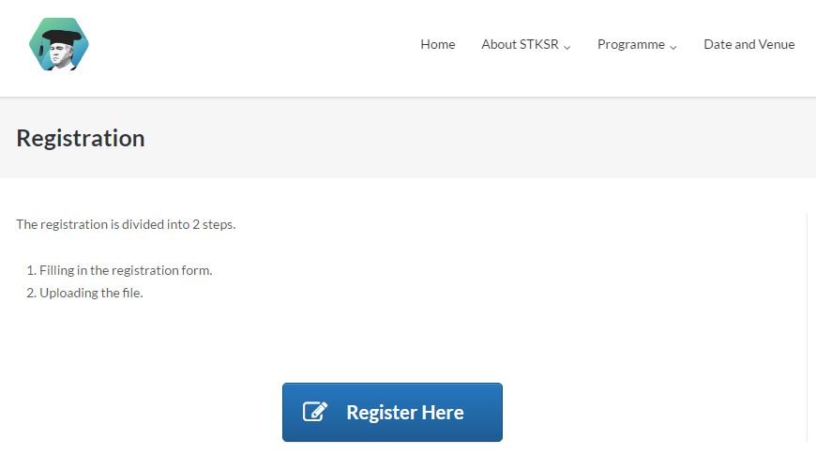
Click here

FIRST PART
In this part, there are several question regarding the basic information of your abstract.
- Please fill the First Author space with the First Author’s full name
- Please fill First Author’s Affiliation with this format:
Department, Institute/Organization, City, Postal Code, Country
- If there are more than one author, please fill other authors’ name and their affiliation with the same format as the first’s
- Please fill the author’s email with your active email. Every information regarding your application will be sent through this email.
- Please fill the author’s number with your active phone number. Please include your country extension number.
- Please fill the title of your paper
- Please choose the category that is related with your paper
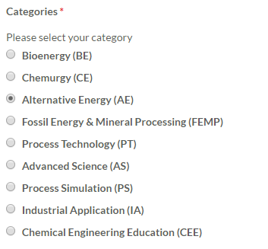
- Please write your abstract in one paragraph within 300 words (maximum).
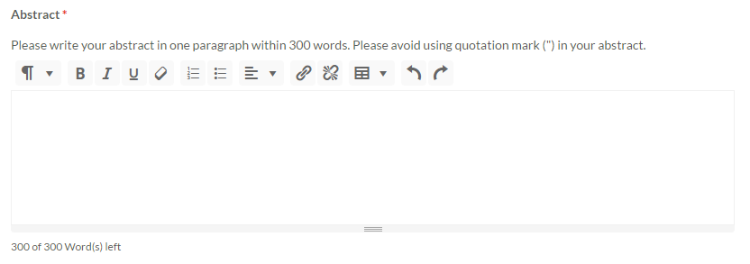
- Please write the keywords of your paper

- Please double check, and click the submit bottom to submit your paper.

SECOND PART

After submit the previous form, you will be lead to the page below. On this part, please upload the abstract file according to the format describe below (at the end of the guideline).

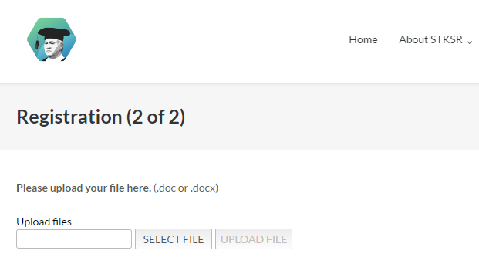
- Please select the abstract file in your device.
Click here

- Please double check the format of the file as the guideline, then upload the abstract file.
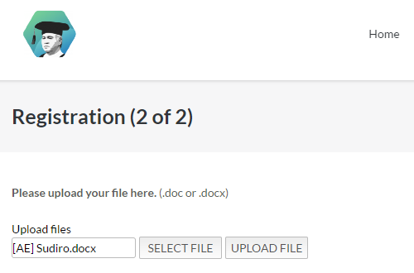
Click here

- Your paper has ben submitted and you have completed the registration of STKSR 2017
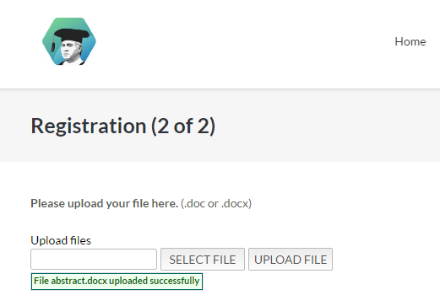

Thank you for your submission!
The information on abstract acceptance will be sent through email on 31th July 2017.

For further information please contact us on :
stksr2017@gmail.com ; stksr@che.itb.ac.id

Guidelines of Abstract Preparation for STKSR 2017

Author 1^{a*}, Author 2ª, and Author 3^{b}

ª Department of Chemical Engineering
Institut Teknologi Bandung, Bandung 40132 Indonesia
^{b}Department of Chemical Engineering
Institut Teknologi Bandung, Bandung 40132 Indonesia

*Corresponding Author’s E-mail: abcdef@che.itb.ac.id

Abstract
For all submissions, you will be asked to submit (1) title, authors, abstract, and keywords and (2) the body of the submission with author information. The paper title should be in 14 points, Times New Roman bold. Author's name and affiliation should be in 10 points Times Roman plain. Leave 12 points of space before and after the paper title, 12 points of space after the author's name(s) and 12 points of space after the author's affiliation(s) (or email address). Note: for the review process leave the author/affiliation section as is. The abstract should summarise the contents of the paper in between 40 and 250 words. Note that paper title, author's name(s) and author’s affiliation(s) should be centered. The abstract should be in 11 points Times New Roman italic and should be justified (left and right flushed). Topics of abstract can be seen in website stksr.che.itb.ac.id

Keywords:Abstract; Acceptance ;Forward; International ; Submitted;Template

File Name : [THEME CODE] Last name of Corresponding Author
File Format : Microsoft Word file

